Software Development Life Cycle (SDLC) models

1. Agile Model
The Agile model is an iterative and incremental approach that focuses on flexibility, collaboration, and delivering working software quickly. It emphasizes frequent communication and adaptation to change over strict adherence to a plan.
Feature | Description
Philosophy | Customer collaboration and responding to change are prioritized over following a strict plan.
Process | Work is broken into small, fixed-length iterations (called Sprints, typically 2-4 weeks).
Output | A potentially shippable product increment is delivered at the end of each iteration.
Ideal Use | Projects with rapidly changing requirements, or when the final scope is not fully defined at the start.
Export to Sheets
Example: Developing a Social Media Application.
- Sprint 1: Build core features (user login, profile creation).
- Sprint 2: Add a basic feed and ability to post text updates.
- Sprint 3: Implement image uploads and a 'like' button.
- Result: The customer gets a working, usable product (or a new set of features) after every few weeks, allowing continuous feedback and adaptation.
Image: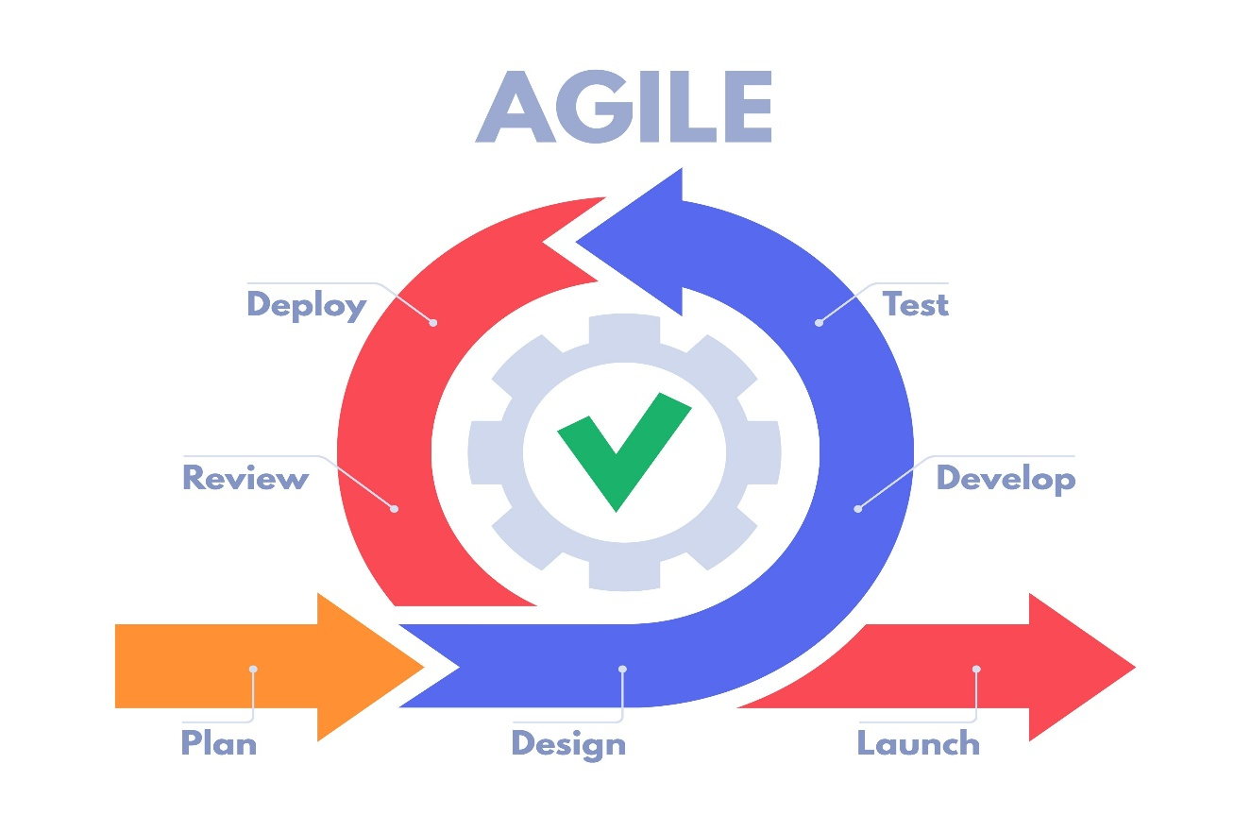

2. Waterfall Model
The Waterfall model is a sequential, linear approach where each phase of development (Requirements, Design, Implementation, Testing, Deployment, Maintenance) must be completed before the next phase can begin. It is simple to understand and use but lacks flexibility.
Phase | Activity
Requirements | Gather and document all necessary requirements.
Design | Design the system architecture, database, and overall structure.
Implementation | Write the code for the software modules.
Testing | Verify the entire system to ensure it meets requirements.
Deployment | Release the software to the customer environment.
Export to Sheets
Example: Developing a highly regulated system like software for a power grid or an air traffic control system.
- Since requirements for such systems are typically fixed, unambiguous, and critical, the Waterfall model's emphasis on thorough planning and detailed documentation in the early stages makes it suitable. Once the requirements are signed off, the team proceeds sequentially with minimal changes.
Image:
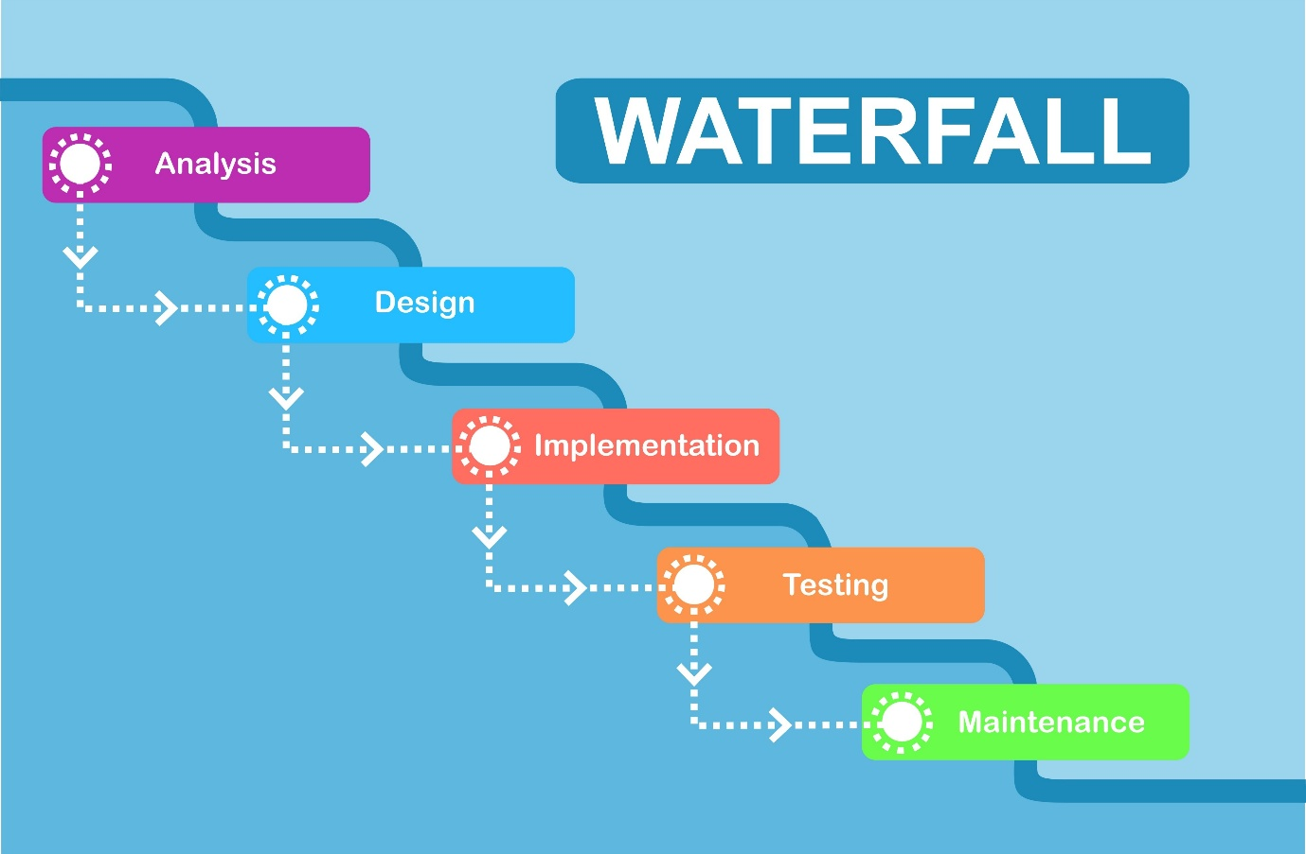

3. V Model (Verification and Validation Model)
The V-Model is an extension of the Waterfall model that executes processes in a V-shape. It emphasizes testing activities that correspond directly to each development phase, ensuring that planning for testing starts early. The left side represents Verification (building the product correctly), and the right side represents Validation (building the correct product).
Verification Phase (Development) | Corresponding Validation Phase (Testing)
Business Requirements Analysis | User Acceptance Testing (UAT)
System Design | System Testing
Architectural Design | Integration Testing
Module Design | Unit Testing
Export to Sheets
Example: Developing software for a medical device or a payroll system.
- These projects require high reliability, precise documentation, and rigorous testing at every level. For example, during the Requirements Analysis phase (left side), the team simultaneously prepares the User Acceptance Test (UAT) Plan (right side) to confirm the final product will meet the user's critical needs.
Image:
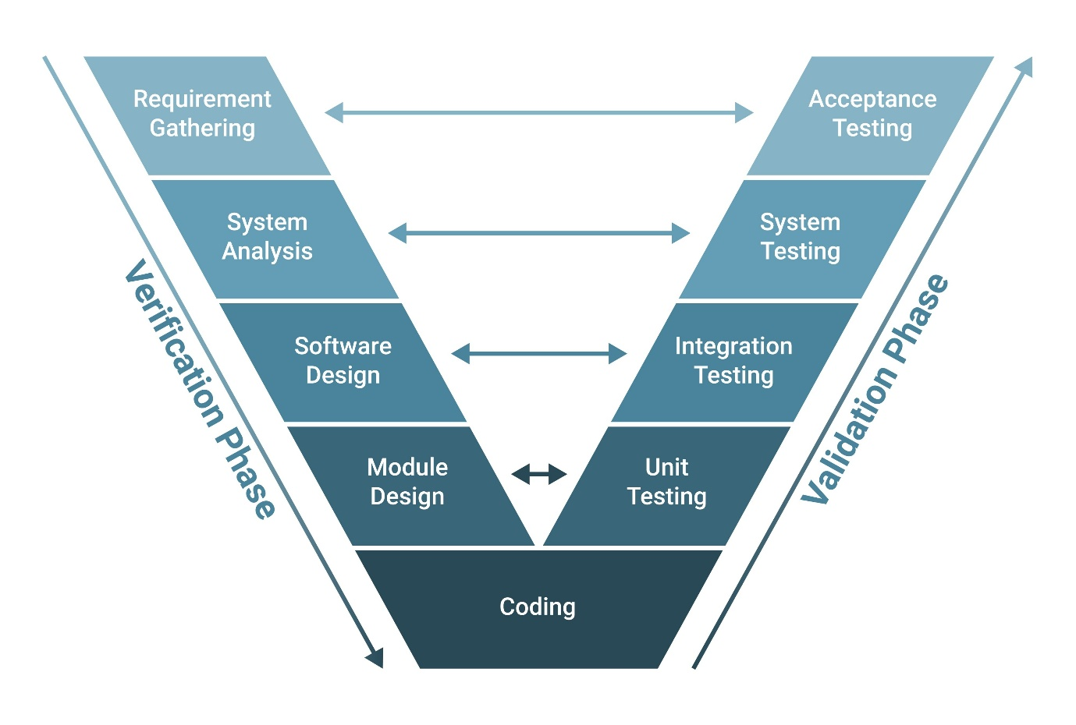

4. Spiral Model
The Spiral Model is a risk-driven process model that combines the iterative nature of prototyping with the systematic control of the Waterfall model. It involves four main phases—Planning, Risk Analysis, Engineering, and Evaluation—repeated in cycles (spirals).
Phase | Focus
Planning | Define objectives and scope for the current spiral.
Risk Analysis | Identify and mitigate risks (a central focus of this model).
Engineering | Develop and test the next version of the product (the actual coding/design work).
Evaluation | Review the results with the customer and plan the next spiral.
Export to Sheets
Example: Developing a large, complex operating system (like early versions of Windows) or a high-budget video game.
- These projects involve high financial risk and unknown technical challenges. In the initial spirals, the focus is on Risk Analysis by building simple prototypes (Engineering) to resolve performance or feasibility issues. Later spirals focus on full development and feature implementation. The iterative cycles allow for continuous risk management and cost control.
Image:
